|  |  |
| --- | --- |
| Big-O Value | Classification |
| O(1) | Constant |
| O(x) | Linear |
| O(x2) | Quadratic |
| O(x3) | Cubic |
| O(x4) | Quartic |
| O(log(x)) | Logarithmic |
| O(xnlog(x)) | Polynomial |
| O(nx),O(xn) | Exponential |
| O(x!) | Factorial |

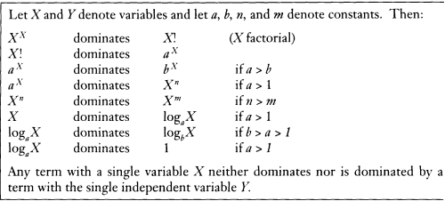

lg(x)=log2(x)